DOCUMENTATION

**DETAILS**

**TEAM MEMBERS**: D. JADHURSHANA

G. JEYA VARSHINI

P. JUDITH LOURD TINA

P. SWATHIGA

**DEGREE/BRANCH**: B.E/CIVIL ENGINEERING

**INSTITUTE NAME**: VELAMMAL COLLEGE OF ENGINEERING AND TECHNOLOGY VIRAGNOOR MADURAI-625 009

**SKILLS**: DIGITAL MARKETING

**Project Details**

**Mail**

* **E-mail**: [brickbuilders04@gmail.com](mailto:brickbuilders04@gmail.com)
* **Password**: Brick_builders@04

**Canva**

* **Brand Name**: Brick builders
* **Canva URL**: https://www.canva.com/design/DAFycSev5A0/frFxAWCKrUWdivqqWouRhQ/edit?utm_content=DAFycSev5A0&utm_campaign=designshare&utm_medium=link2&utm_source=sharebutton

Creating a mail id

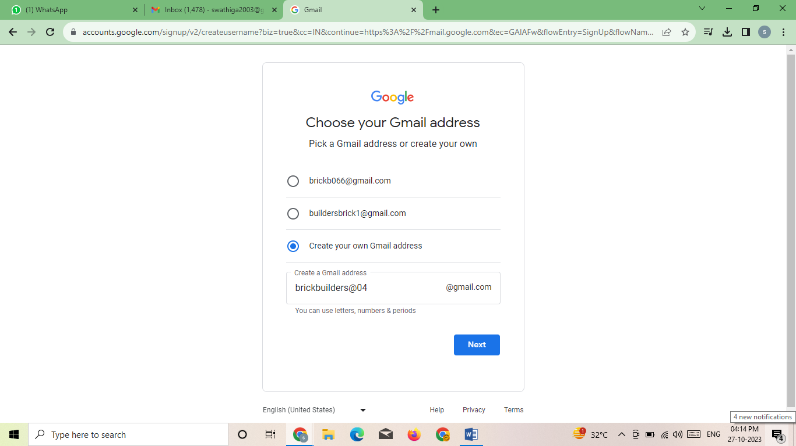

Opening the Canva site

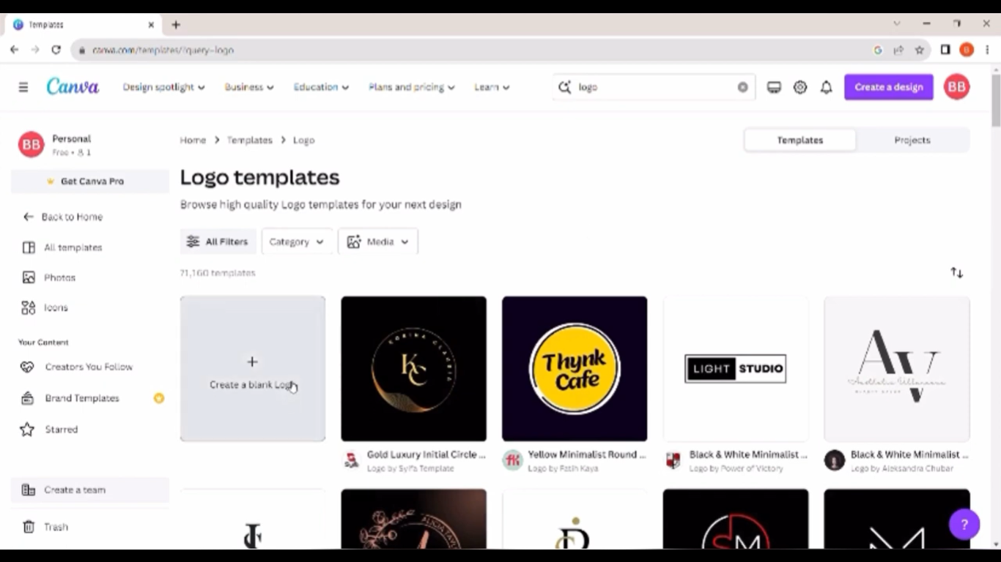

Opening a blank logo template

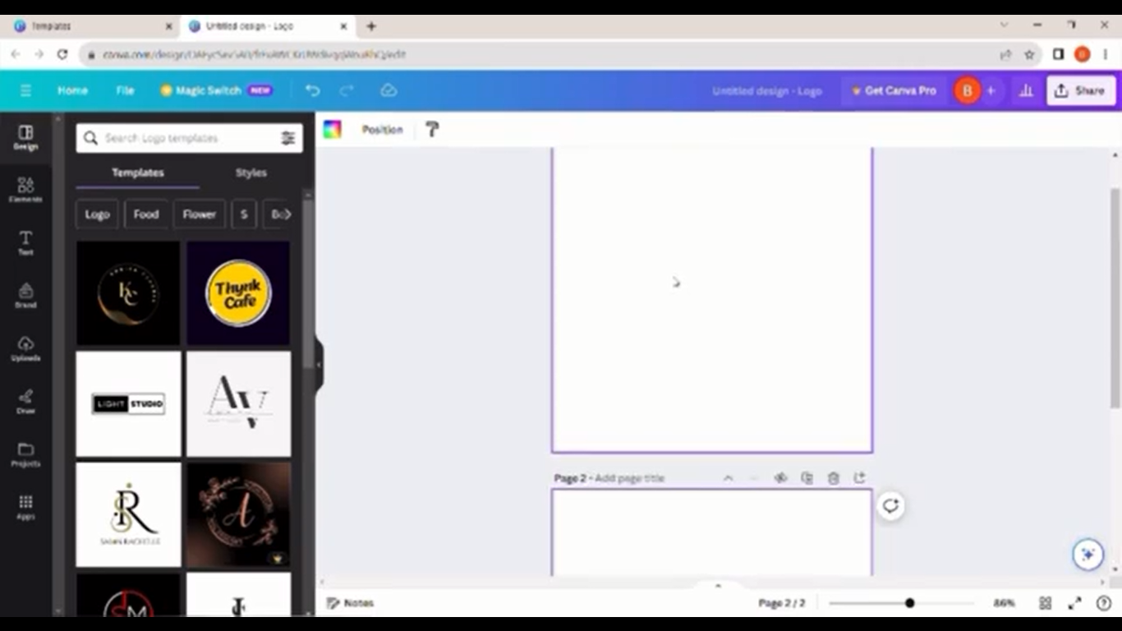

# Choosing letters for logo

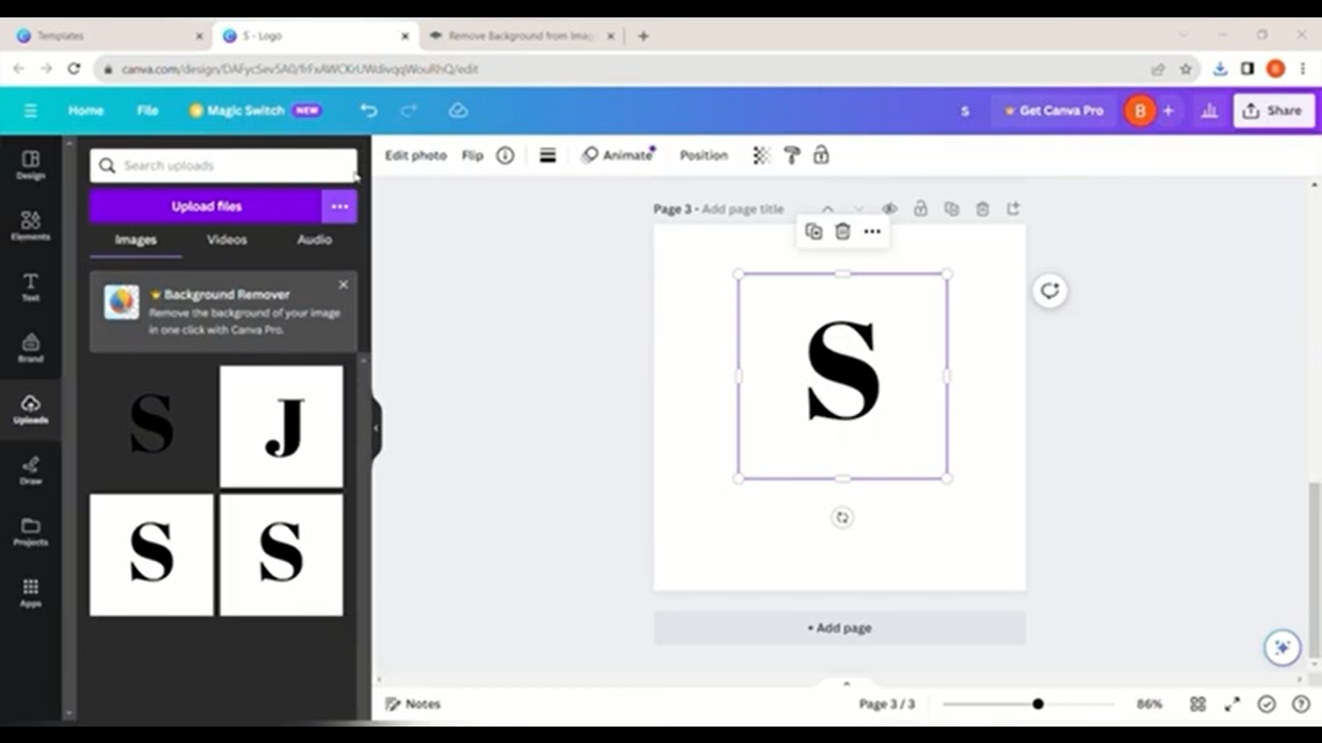

Merging of letters in Canva

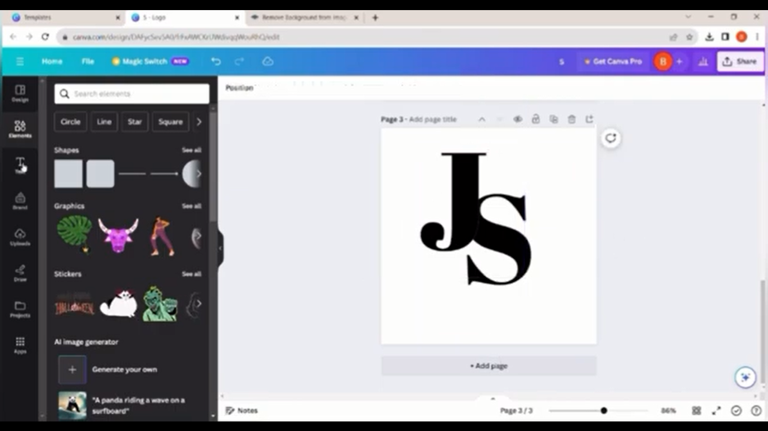

Inserting our brand name

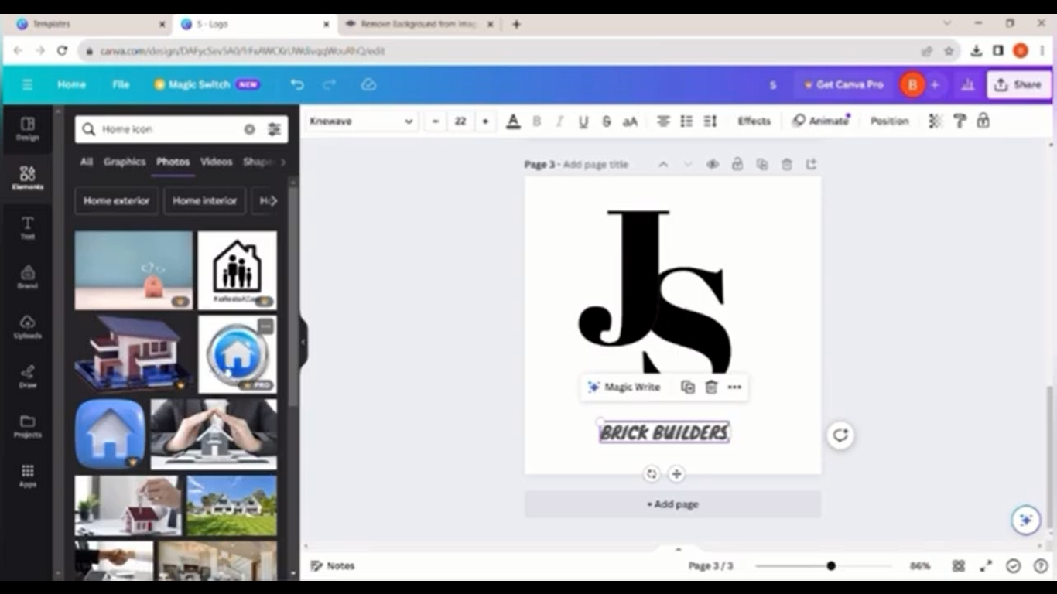

# Setting out effects

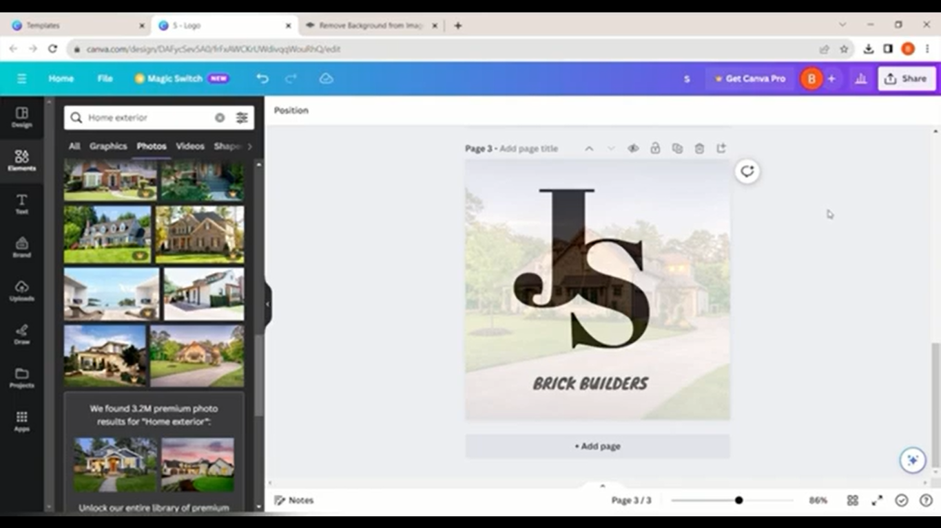

Uploading the video in youtube

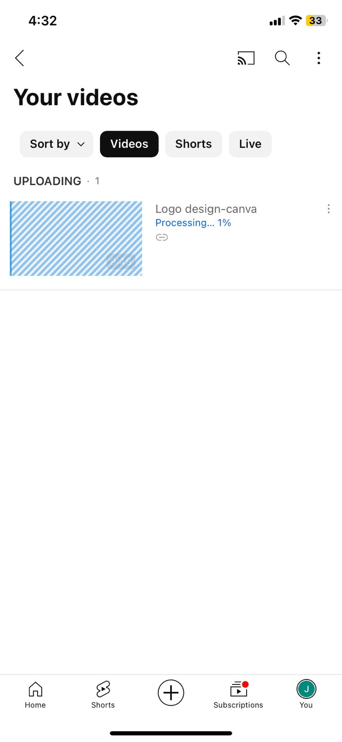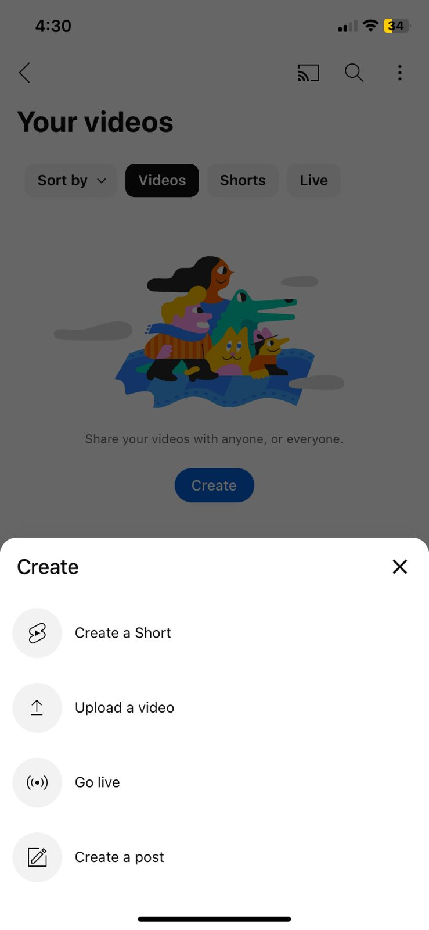

# Uploaded video

